Taking care of your waste water supply in Dunbar

Project reference

**Horizons Dunbar Sewer Upgrade**

This work is being carried out by Scottish Water’s commercial subsidiary, Scottish Water Horizons, and our deliver partner George Leslie

Address 1

Address 2

City

Postcode

8th April 2024

What we are doing

We have carried out maintenance and upgrades to the sewer network in your area and now we require to **close a section of Elder Street and suspend parking**, near your property to conduct remedial works on the road.

|  |
| --- |
| When are we doing it |

Work will begin in Elder Street on Mon 14 April and move along onto Pine Street in phases, lasting approx. four days.

|  |
| --- |
| What happens next |

* Your water supply and drainage services from your kitchen and bathroom should not be affected by our work.
* We are required to **close a section of Elder Street to all public vehicles and footpath** during the dates above. (see overleaf) then work on Pine St in phases, suspending parking as we move along.
* **Pedestrian access to properties within the road closure will be maintained**, however parking within this area will not be permitted during our work.
* Please follow all signs put in place.

Thank you for your patience and understanding while we carry out this remedial work.

Alastair Kerr

Community Engagement

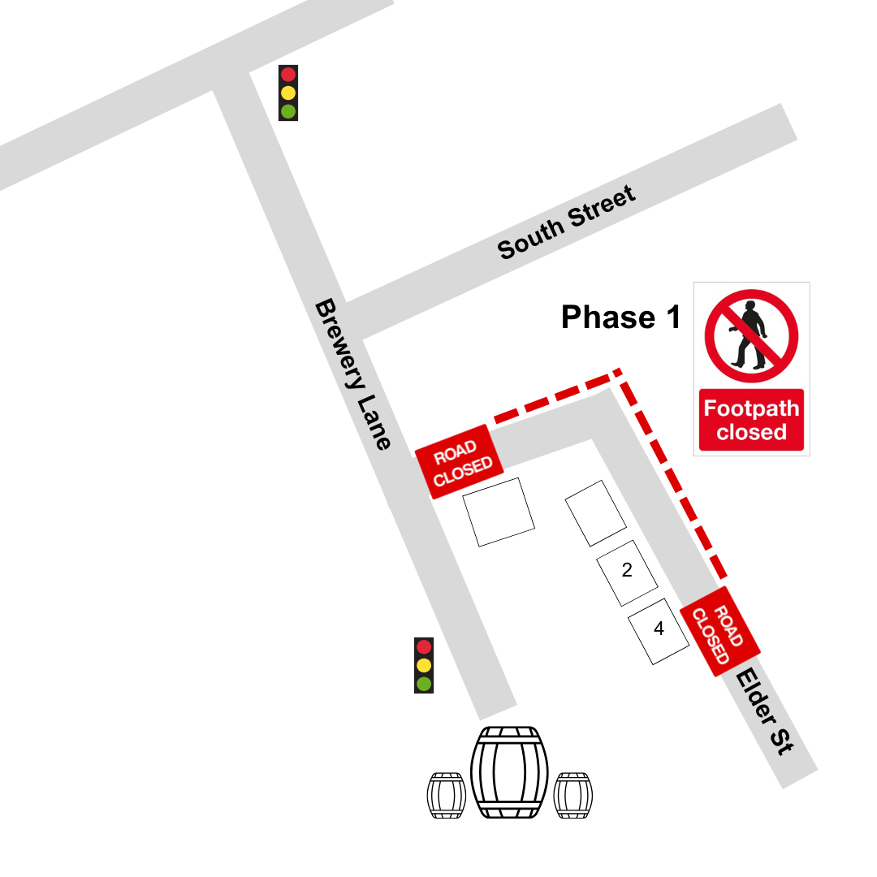

For illustrative purposes only

